The University with promising future and full of happiness! SMART GNU

Fall 2018
Admission Guide for International Students

2018  Admission Guide for International Students | Application Information 1. Notices 1  2. Admission Process 2  3. Application Eligibility 2  4. List of Majors and number to be admitted 3  5. Required Documents 4  6. Evaluation and Screening 6  7. Application Fees 6  8. Acceptance Notification and Tuition Payment 6  Miscellaneous Information 1. Tuition Status 7  2. Scholarships Information 7  3. Student Dormitory Information 7  4. Campus Life Guide for International Students 8  5. Offices and Contact Information 9  Forms 1. Application Form 10  2. Academic Performance Plan  11  3. Tuition Fee Promissory Letter 13  4. Letter of Consent (TOEFL Score Verification) 14  <Campus Guide> 15  <Questionnaire> 16

Notices

- All documents submitted must be original. However, if non-originals must be submitted, confirmation must be received by presenting the original.
- If the required documents are incomplete and screening fee is not paid, applicants are not eligible for acceptance. If Korean language course student‘s documents which were submitted to IKLC (Institution of Korean Language and Culture) overlap with those of required documents for application for International Students Admission, they can be regarded as the application documents for this Admission.(Application should be made by deadline and there should be no defects on the documents.)
- The screening and decision-making processes will not be released and all submitted documents will not be returned. (Even if not accepted, students cannot ask for the relevant documents back, so please keep that in mind.)
- Emergency contact may be necessary during the application period. Applicants should include a contactable phone number for the Office of Admissions. Applicants are responsible for disadvantages caused by contact phone number changes, contact interruption, not confirming the list of passers, or failure to follow immigration procedures.
- Individual contact on the progress of the screening process will not be made. Thus, please check our web site from time to time during the application period.
- This guide is written in Korean, English, Chinese, Vietnamese and Russian . If there is a difference in interpretation, the Korean guide shall govern.
- If the submitted documents contain false information or if other illegal means were used for admission, admission will be rejected.
- Application results can be found on the GNU web site. After acceptance students must pay the tuition fees to the designated banks by the due date.
- Students who receive acceptances from several universities including GNU must enroll in one university. In case of dual enrollment, all acceptances from universities will be cancelled.
- Those who submitted a Certification of Expected Graduation must submit the Certificate of Graduation before admission.
- It is mandatory for all international students to maintain proper health insurance coverage during their study. If you contribute to a private health insurance plan, related documents (insurance policy or insurance certificate, etc.) must be submitted at the time of admission.
- Students cannot take a leave of absence during their first semester directly after admission. (However, leave of absence due to disease, military service or etc is allowed)
- Matters other than those specified in the Admissions Guide are subject to the separate regulations of our university.
※ Submissions and Inquiries
✤ Tel: +82-55-772-0277, Fax +82-55-772-0269
✤ Address: Office of International & External Cooperation, Gyeongsang National University
501 Jinju-daero, Jinju, Gyeongnam, 52828, South Korea.
✤ E-mail: passfi@gnu.ac.kr
✤ Web: http://publiceng.gnu.ac.kr
※ Support for International Students (Visa, Insurance Issues, etc.)
✤ Tel: +82-55-772-0272, Fax +82-55-772-0269
✤ Address: Office of International & External Cooperation, Gyeongsang National University
501 Jinju-daero, Jinju, Gyeongnam, 52828, South Korea.
✤ E-mail: 7720723@gnu.ac.kr
✤ Web: http://publiceng.gnu.ac.kr

Admission Process

Classification | Schedule | Place | Note
Application &  Submission | 2018. 5. 23. ~ 6. 8. | Office of International & External Cooperation.  (Building 1, 2rd floor) | ▪Registered Mail, Courier Service or In person (No faxes)  (Closed on Saturdays, Sundays and Korean holidays)  ▪Application fee must be paid by June. 8(Fri.)
Screeing Eligibiliity | 2018. 6. 11. ~ 6.14.
Result Announcement  on Screening  Eligibility | 2018. 6. 15. | http://publiceng.gnu.ac.kr | ▪Notified individually
Document  Screening | 2018. 6. 18. ~ 7. 6. | Relevant department/faculty | ▪Including Screening Performance videos (For applicants for the Department of Ethnic Dance)
Acceptance  Notification | 2018. 7. 10. | http://publiceng.gnu.ac.kr | ▪Website
Tuition  Payment | 2018. 7. 24. ~ 7.25. | Designated Banks  (to be released) | ▪Print the invoice (bill):  7. 24. ~ 7. 25.  ▪During banking hours.

※ The above schedule may change depending on the school situation.
Please check notices on the website (http://publiceng.gnu.ac.kr)
Application Eligibility

1. Nationality: Applicants and both their parents should have non-korean nationality.
※ Applications should be completed by the due date. If a student has dual citizenship with Korea, he or she is not eligible to apply.
※ If one parent is deceased, his/her nationality is not considered.
2. Educational Background
Classification | Eligibility
Freshman | • Students who have completed all courses corresponding to those of elementary, middle and high school in Korea or a foreign country  (including expected graduates in August. 2018)
Transfer student  (3rd grade/ Junior) | • Students who have completed or are expected to complete 2 years or  4 semesters at a 4–year university in Korea or a foreign country  • Students who have graduated or are expected to graduate from a 2-year college  ※ Students at our university are not eligible for this track  (including those taking semesters off).

3. Language Proficiency: One or more of the requirements should be satisfied.
Calssification | ① Level of TOPIK  (Test of Proficiency in Korean) | ② Scores of Authorized English Proficiency Test |  |  |  |  |  | ③ Scores of Korean Language Course  (Institution of Korean Language and Culture at GNU)
 |  | TOEFL |  |  | IELTS | TEPS | TOEIC
 |  | PBT | CBT | iBT
General  Majors | Level 3 or higher | 550 | 210 | 80 | 5.5 | 550 | 650 | Acquire a score of 140 or higher out of 200
the Department of Ethnic Dance | Level 1 or higher | 300 | 110 | 40 | 3.0 | 300 | 360 | Acquire a score of 100 or higher out of 200

※ Those who didn’t submit language requirements by the end of days of Eligibility Screening can submit them during Document Screening period through discussion with responsible person in OIEC.
※ Those whose native language is English need not submit the above documents (from USA, Canada, UK, Australia, New Zealand, Ireland, and South Africa).

List of Majors and number to be admitted

1. List of Majors 【 New Admission / Transferred 】

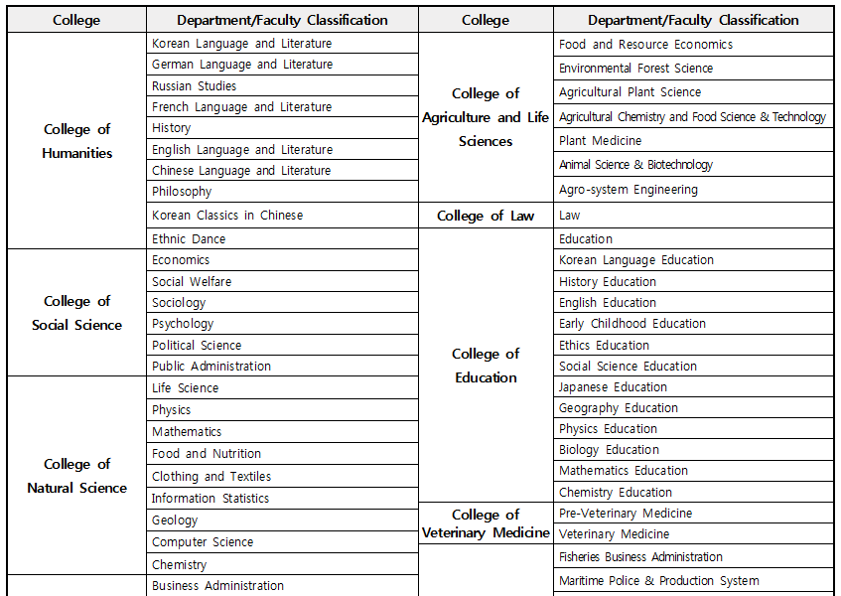
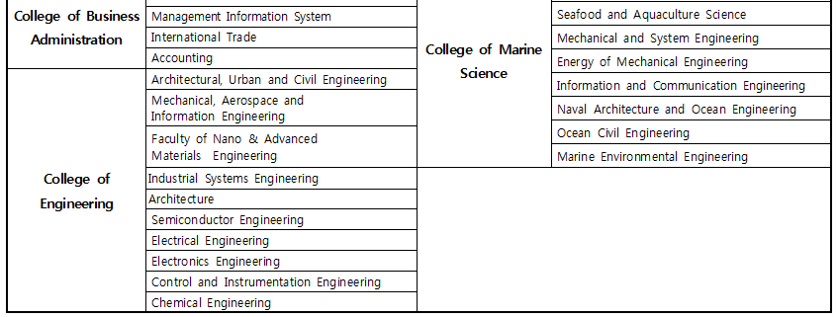

※ For applicants to faculties, their majors are subject to the regulations of our university.
※ The Architecture major is a 5-year program. The Veterinary Medicine major is divided into the preparatory course (2 years) and the regular course (4 years).
※ Only those with Japanese nationality are eligible to apply to the Japanese Education Department of the College of Education.

2. Number to be admitted: Several per department (No limit)
※ Departments not specified above cannot be applied to (College of Medicine, College of Nursing, College of Pharmacy, and the Art, Music and Physical Education Departments of the College of Education).
Required Documents Fill out in Korean or English. Documents not in Korean or English should be translated into Korean and notarized.

[△: For relevant students]
No. | Items | Freshman | Transfer students | Note
① | Application Form | O | O | [Form 1] Fill out in Kor. or Eng.
② | Academic Performance Plan | O | O | [Form 2] Fill out in Kor. or Eng.
③ | High school Diploma or Certificate of  (Expected) Graduation | O | ✕
④ | Official Academic Transcript from High School | O | ✕
⑤ | Certificate of (Expected) Completion  or Certificate of (Expected) Graduation from College | ✕ | O | Expected graduates must submit the Certificate of Graduation/Completion by Feb. 28 (Wed.) 2018
⑥ | Academic Transcript from College | ✕ | O
⑦ | TOPIK Results (Level 3 or higher) | O | O | ⋅Submit one or more of the three certificates  ⋅Scores/grades after  2016.5.23. are considered valid.
 | Certificate of Korean Language Courses of the IKLC (Institution of Korean Language and Culture) at GNU
Certified English transcripts
(TOEFL, IELTS, TEPS, TOEIC)
⑧ | Letter of Consent for TOEFL Score Verification [Form 4] | △ | △ | If not submitting a transcript for TOEFL (iBT)
⑨ | Copy of the applicant‘s passport | O | O
⑩ | Copy of the applicant's alien registration card | △ | △ | Only for those currently living in Korea
⑪ | Documents verifying foreign nationality of both of the applicant’s parents | O | O | Passport or certificates of nationality
⑫ | Certificate of Family Relation | O | O
⑬ | Certificate of Bank Balance | O | O | To be issued in the name of one’s own or parents’ names
⑭ | Employment certificate or business registration certificate of sponsor | O | O
⑮ | Tuition fee promissory letter | O | O | [Form 3] Fill out in Kor. or Eng.
⑯ | Performance videos (Certified by the principal or authorized head) | △ | △ | For applicants for the Department of Ethnic Dance
⑰ | Questionnaire | △ | △ | Not Mandatory

※ Write documents number on the right side at the top.
(They should be organized in numerical order.)
※ All documents to be submitted must be original. Documents not in Korean or English should be
translated into Korean and notarized.
※ The original Certificate of Bank Balance(⑬): The original Certificate of Bank Balance should show a balance of over USD 18,000 deposited under the name of the applicant or financial guarantor , a certificate of remittance to Korea or an exchange certificate.(It should be the one issued on the day after 1st March. 2018 )
※ Those who need to obtain a visa should deposit the above amount before admission
※ If the name on the submitted documents does not match the student’s official identification, the student must submit additional documents proving that the names indicate the same person.

[③,⑤]<Notes on the Submission of High School Certificates>
⋅ For those graduating from high schools in China: Please refer to the following websites.
- Education Certification Center: http://www.chsi.com.cn
- China Academic Degrees and Graduate Education Information: http://www.cdgdc.edu.cn
- Confucius Institute in Seoul (Certification agency in Seoul): http://www.cis.or.kr
⋅ Accepted students with a Certificate of Expected Graduation at the time of application must submit the Certificate of Graduation/Completion by August. 31(Fri.) 2018

⑫<Legal documents verifying the relationship between the applicant and his/her parents>
⋅ China: Kinship notarization ⋅ Indonesia: Certificate of family relation (KARTU KELUARGA)
⋅ Mongolia: Kinship certificate ⋅ Vietnam: Birth certificate(So Ho Khau) or (Giay khai sinh)
⋅ Philippines: Family Census ⋅ Pakistan: Family Certificate
⋅ Kyrgyzstan, Kazakhstan, Uzbekistan, Ukraine, Thailand: Birth certificate
◆ The above documents should be issued within 6 months of the time of application
◆ If the applicant's parents are deceased or divorced, verifiable certificates should be submitted.

<Notes on the Submission of documents issued from foreign countries>
⋅ All documents to be submitted must be original. Documents not in Korean or English should be translated into Korean and notarized.
⋅ If your home country is a member of the Apostille Convention, please submit an Apostille confirmation letter.
⋅ If your home country is not a member of the Apostille Convention, please submit a confirmation letter from the Korean Embassy.
※ To check if your home country is a member of the Apostille Convention, please visit: http://www.hcch.net - Apostille Section - Status Table

◆ In addition to those above, additional documents may be required during eligibility screening.
Evaluation and Screening

1. Evaluation Criteria
Departments | Steps | Criteria
All | Step 1 | Screening for Eligibility of application
General | Step 2 | Language proficiency 50%, Academic Performance Plan 50% (Total 100)
Department of Ethnic Dance |  | Language proficiency 10%, Academic Performance Plan 30%, Performance test 60% (Total 100) (Performance test replaced by videos submitted)

2. Screening
(A) Those accepted as eligible applicants at Step 1 (document screening) move on to Step 2, where each department selects those who have an average of 70% or higher.
(B) Applicants with first preference to the major will be selected first, and those with second preference will be reevaluated for screening. (Applicants with third preference will be selected in the same way.)
Application Fees

◈ Fees: 70,000KRW
◆ Bank Name: Nong-hyup (NH bank) National Agricultural Cooperative Federation
◆ Swift Code: NACFKRSE
◆ Account Number: 301-0212-4832-41
◆ Account holder name: Gyeongsang National University
◆ Sender: should be identical to the applicant’s name
※ The application will not be processed unless the fee is paid.
※ ₩28,000 will be returned to those who are not accepted at Step 1 (Screening for Eligibility of application).
Acceptance Notification and Tuition Payment

1. Acceptance Notification
(A) Date and time: July. 10(Tue.) 2018 20:00 (subject to change)
(B) Place: Notice menu on the web page: (http://publiceng.gnu.ac.kr)
(C) Please carefully refer to and comply with all guidelines announced at the time of acceptance notification.
2. Issuance of Acceptance Letter
(A) Period: in the middle of August. 2018
(B) Department in charge: Team of International Exchange, Office of International and External Cooperation
(C) Contact: +82-55-772-0272
3. Payment of Tuition
(A) When: July. 24 (Tue.) ~ July. 25 (Wed.) 2018 (during banking hours)
(B) Where: Designated banks (to be announced)
(C) How: Print the invoice (bill) from the GNU web site and pay at the designated bank.
(D) If a student does not pay the tuition fees by the due date, admission will be withdrawn.
Miscellaneous Information

【Tuition Status】
[Based on the first semester 2018, (Won)]
Classification  College | Category | Registration fee | Tuition fee | Note
College of Humanities | Humanities and Social Science |  | 1,633,000
 | Humanities and Social Science  (Department of Ethnic Dance) |  | 1,876,000
College of  Social Science | Humanities and Social Science |  | 1,633,000
College of  Natural Sciences | Natural Science |  | 2,012,000
 | Engineering  (Department of Computer Science) |  | 2,165,000
College of Business | Humanities and Social Science |  | 1,633,000
College of Engineering | Engineering |  | 2,165,000
College of Agriculture and Life Sciences | Humanities and Social Science  (Department of Food and Resources Economics) |  | 1,633,000
 | Natural Science |  | 2,012,000
 | Engineering |  | 2,165,000
College of Law | Humanities and Social Science |  | 1,633,000
College of Education | Humanities and Social Science |  | 1,633,000
 | Natural Science - Physical |  | 2,012,000
 | Art and Music |  | 2,208,000
College of Veterinary Medicine | Natural Science(Pre-Veterinary Medicine) |  | 2,503,000 | Freshman
 | Natural Science(Veterinary Medicine) |  | 2,932,000 | Transfer
College of  Marine Science | Humanities and Social Science  (Department of Fisheries Management) |  | 1,633,000
 | Natural Science |  | 2,012,000
 | Engineering |  | 2,165,000

【Scholarships】

Scholarship Type | Eligibility | Scholarship Amount
TOPIK 4 | New students | Full tuition exemption for first semester
 | Enrolled students with GPA 3.3 or higher | Half tuition off
 | Enrolled students with GPA 3.8 or higher | Two-thirds tuition off
TOPIK 5~6 | New students | Full tuition off for first semester & living cost support  (500,000 KRW / one time)
 | Enrolled students with GPA 3.0 or higher | Half tuition off
 | Enrolled students with GPA 3.5 or higher | Two-thirds tuition off
 | Enrolled students with GPA 4.0 or higher | Full tuition exemption for one semester
Sibling Scholarship | When more than two siblings from a family registered at GNU’s undergraduate courses, the eldest shall  receive Tuition ½ exemption on condition of GPA 2.5 in the previous semester.
Special  Scholarship | ISA Executives Scholarship | Amounts are subject to the separate regulations of our university.

【Student Dormitory Information】
(A) Capacity: 4,729 (Based on the first semester 2017)
- Gajwa Campus (capacity: 3,944)
- Chilam Campus (capacity: 255)
- Tongyeong Campus (capacity: 530)
※ Dormitory is available to all interested international students (with priority)
(B) Application for dormitory: when filling out the form of application for admission support, you can check it on the form.
(C) Boarding expenses (subject to change)
- Gajwa Campus: General dorm: ₩376,290~515,040 (can vary depending on dormitory facilities)
BTL dorm: ₩526,140~612,720 (double room)
<Optional meal plans(6 types), in the case of 3 meals/day for one semester : ₩690,900>
- Chilam Campus: ₩1,830,390 (single room), ₩1,255,410 (double room)
- Tongyeong Campus: ₩868,000~1,271,000
▪ Campus Life Guide for International Students ▪
◆ Freshman Orientation (March and September)
- Target: All foreign freshmen
- Contents: Immigration/basic residence rules (public etiquette), medical insurance, course registration, campus tours, Korean language curriculum, culture experiences, events, academic support, and guidance throughout campus life

◆ GNU Buddy (Student Assistant) program
- Cross-cultural learning and exchange program through one-to-one matching of Korean students and foreign students

◆ Korean education program
- Regular courses: basic subjects for general education by academic area to improve Korean proficiency
- Customized courses : practical Korean, Korean writing, and how to write papers by learner level
- Special courses: Test of Proficiency in Korean (TOPIK)
⇒ area-specific intensive training; scholarships granted to students who achieve excellent grades.

◆ 「Gyeongsang Speech Contest for International Students」
- In cooperation with Jinju City, GNU holds this event every year for international students and residents to increase their interest in Korean and improve their Korean proficiency.

◆ Culture Experience Program
- Exploration of the local culture
- Tour of industries
- Temple stay, etc.

◆ Institute of International Students Support Program
- Traditional holidays (Lunar New Year, Thanksgiving), sports days, college festivals, farewell party etc.
- Event of 「International Students Day」

【Offices and contact Information】 <055-772-****>
Colleges | Departments | Office | Colleges | Departments | Office
College of Humanities | Korean Language Literature | 1020 | College of Agriculture and Life Sciences | Food and Resource Economics | 1840
 | German Language and Literature | 1040
 |  |  |  | Environmental Forest Science | 1850,1860
 | Russian Language and Literature | 1050
 |  |  |  | Agricultural Plant Science | 1870,1910
 | French Language and Literature | 1060
 |  |  |  | Agricultural Chemistry and  Food Science & Technology | 1900,1960
 | History | 1080
 | English Language and Literature | 1120
 |  |  |  | Plant Medicine | 1920
 | Chinese Language and Literature | 1180
 |  |  |  | Animal Science & Biotechnology | 1880,1940
 | Philosophy | 1150
 |  |  |  | Agro-system Engineering | 1890,1930
 | Korean Classics in Chinese | 1160
 |  |  | College of Law | Law | 2020
 | Ethnic Dance | 1170
 |  |  | College of Education | Education | 2130
College of Social Sciences | Economics | 1220
 |  |  |  | Korean Language Education | 2150
 | Social Welfare | 1240
 |  |  |  | History Education | 2170
 | Sociology | 1250
 |  |  |  | English Education | 2190
 | Psychology | 1260
 |  |  |  | Early Childhood Education | 2240
 | Political Science | 1270
 | Public Administration | 1280
 |  |  |  | Ethics Education | 2140
College of Natural Sciences | life Science | 1320  1340,1350
 |  |  |  | Sociology Education | 2160
 |  |  |  | Japanese Education | 2200
 | Physics | 1400
 |  |  |  | Geography Education | 2180
 | Mathematics | 1420
 | Food and Nutrition | 1430
 |  |  |  | Physics Education | 2210
 | Clothing and Textiles | 1450
 |  |  |  | Biology Education | 2230
 | Information Statistics | 1460
 |  |  |  | Mathematics Education | 2250
 | Geology | 1470
 |  |  |  | Chemistry Education | 2220
 | Chemistry | 1480
 | Computer Science | 1380 | College of Veterinary Medicine | Pre-Veterinary Medicine | 2370
College of Business | Business Administration | 1520
 |  |  |  | Veterinary Medicine | 2340
 | Management Information System | 1530
 |  |  | College of Marine Science | Fisheries Business Administration | 9160
 | International Trade | 1540
 | Accounting | 1550
 |  |  |  | Maritime Police & Production System | 9180
 | Industrial Business Administration | 1515
 |  |  |  | Seafood and Aquaculture Science | 9140,9150
 |  |  |  | Mechanical and System Engineering | 9100
College of Engineering | Architectural, Urban and Civil Engineering | 1750  1770,1790
 |  |  |  | Energy of Mechanical Engineering | 9110
 | Mechanical, Aerospace and Information Engineering | 1620,1640  1370 |  | Information and Communication Engineering | 9170
 | Nano & Advanced Materials Science | 1660,1680  1650 |  | Naval Architecture and Ocean Engineering | 9190
 | Industrial Systems Engineering | 1690 |  | Marine Civil Engineering | 9120
 | Architecture | 1760 |  | Marine Environmental Engineering | 9130
 | Semiconductor Engineering | 1730 | International students business | Office of International and External Cooperation | 0275
 | Electrical Engineering | 1710 | Tuition | Office of Finance | 0394
 | Electronics Engineering | 1720 | Scholarships/  School expenses | Office of Students | 0176
 | Control and Instrumentation  Engineering | 1740 | School affairs/ Classes | Office of Student Affairs | 0142
 |  |  | Dormitory | Student dormitory(Gajwa) | 0706
 | chemical Engineering | 1780

Form 1 - Application Form

Application for International Students Admission to
Gyeongsang National University
 |  | Fall Semester 2018 |  |  |  |  |  | Application No. |  |  | ※should be blank
Personal  Information | Name | Korean |  |  |  |  |  |  |  |  | Photo  (3×4㎝)
 |  | English
 | Date of Birth  (Month / Day / Year) |  |  |  |  | Place of Birth
 | Sex |  | □ Male  □ Female |  |  | Passport No.
 | Nationality |  |  |  |  | E-mail
 | Phone |  |  |  |  | Mobile
Mailing Address
(Home or in Korea)
 | Current Resident In Korea |  | □ Yes  □ No |  | Alien Registration No. |  |  |  | (If you have)
 | Guardian |  | Name |  | Relationship |  |  | Mobile
Application Information
Application category |  | □ Freshmen □ Junior Transfers
Desired Major |  | □ The First choice college department  □ The Second choice college department  □ The Third choice college department
Language Skilll |  | TOPIK |  | Level
 |  | Korean language Institution |  | University Score  Period:
 |  | English |  | □ TOEFL : □ PBT □ CBT □ iBT / □ TEPS / □ IELTS / □ TOEIC Score
Dormitory |  | □ Yes □ No
Educational Background : Since High School
Level of Education |  | Name of School |  |  |  | Country (City) |  |  |  | Period of Education
 |  |  |  |  |  |  |  |  |  | ~
I affirm that the information I have provided on this application, including personal statements and any other information, is complete and accurate and is my own work. I understand that submission of incomplete or inaccurate information is sufficient cause for revocation of admission or enrollment.

Date: (yyyy-mm-dd)
Name of Applicant: (Signature)
To the President of Gyeongsang National University

Form 2 - Academic Performance Plan

Academic Performance Plan

※ Please TYPE or WRITE clearly in Korean (English).
Name
Nationality
Korean Proficiency | Excellent_________ Good_________ Fair________ Poor________  TOPIK Score __________Level
Desired Major | The first preference :  College ___________ Department(Division)_____________ Major______________
The second preference :
College __________ Department(Division)____________ Major_______________
The third preference :
College __________ Department(Division)____________ Major_______________

Purpose of Application
The first preference :
The second preference :
The third preference :

Study Plans in Korea
The first preference :
The second preference :
The third preference :
Future Plans after Graduation
The first preference :
The second preference :
The third preference :

Form 3 - Tuition Fee Promissory Letter

Tuition Fee Promissory Letter

 | Applicant
 | Name |  | Sex
 | Date of Birth |  | Nationality
Please write the name of the person(including yourself) or organization that
will be responsible for your tuition fee and living expenses.

o Name :
o Relationship :
o Occupation :
o Address :
o Phone Number :

I guarantee that I will be responsible for the above-named applicant's tuition fee
and living expenses for the duration of the whole program.

Date : (yyyy-mm-dd)

Guarantor name :

Signature :

To the President of Gyeongsang National University

Form 4 - Letter of Consent for TOEFL Score Verification

Letter of Consent for TOEFL Score Verification

■ This form is a letter of consent for GNU to verify the TOEFL Score of applicants who submitted an online TOEFL Score report.
■ Applicants who submitted an online TOEFL Score report must provide their ID (User name) and Password for ETS (http://www.ets.org)
■ The ID (User name) and Password provided will only be used to verify the TOEFL score.
■ Please change your password after July. 10 (Tue.) 2018.

Name | (Korean)
 | (English)
Mobile Phone
Examinee´s Number |  | Department
TOEFL (iBT)  Score |  | TOEFL (iBT)  Test Date
ETS ID (user name) |  | ETS Password

I have reviewed all of the above details
and I authorize the Office of International & External Cooperation of GNU to verify my TOEFL (iBT) Score

Date:
Name:
Signature:

Campus

 | Gajwa Campus |  |  |  | Tongyeong Campus
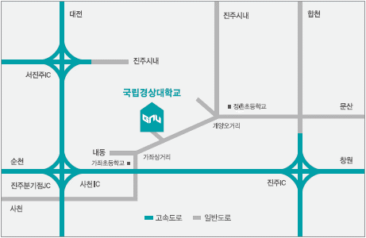 |  |  |  | 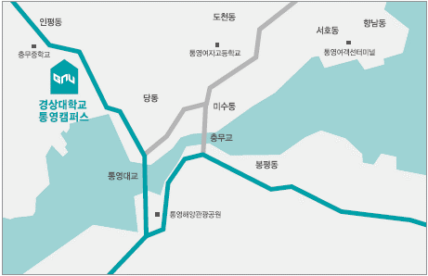
【Gajwa Campus】
Express Bus Terminal | - Bus: across from the Express bus terminal take bus No. 170 (15 min.)  - Taxi: 10 min.
Intercity Bus Terminal | - Bus: Walk 5 minutes to NamGang(river) Bridge and take bus No. 130, 134, 141, 145, or 171  - Taxi: 20 min.
Gaeyang Bus Stop | - Bus: Take bus No. 130, 134, 141, 145, 170, or 171  - Taxi: 3 min.  - Walk: 10 min.
Jinju Station | - Bus: Take bus No. 126, 127, 128, 131, 134, or 151  - Taxi: 5 min.
Sacheon Airport | - Airport shuttle: 15 min.  - Taxi: 10 min.
※ By Car
- Seoul, Daejeon Area: Take Gyeongbu Expressway → Daejeon Tongyeong Expressway → Changwon Namhae Expressway, Jinju JC → Jinju IC → Pass through the toll gate → Drive towards Sachon for 2km
- Busan, Ulsan, Changwon Area: Take Namhae Expressway → Jinju IC → Pass through the toll gate → Drive towards Sachon for 2km
- Gwangju, Suncheon Area: Take Namhae Expressway → Jinju IC → Pass through the toll gate → Drive towards Sachon for 2km
【Chilam Campus】
Express Bus Terminal | - Walk: 3 min.
Jinju Station | - Taxi: 10 min.
Intercity Bus Terminal | - Bus: Walk 5 minutes to NamGang(river) Bridge and take bus No. 130, 134, 141, 145, or 171  - Taxi: 10 min.
【Tongyeong Campus】
Intercity Bus Terminal | - Bus: Take bus No. 400, 409, or 420
Sacheon Airport | - Limousine or bus service  (For more inquiries, call to intercity bus terminal of Tongyeong ☎055-644-4808)

Office of International & External Cooperation, 501
Jinju-daero, Jinju, Gyeongnam, 52828
Tel: +82-55-772-0277, Fax: +82-55-772-0269
http://eng.gnu.ac.kr / http://publiceng.gnu.ac.kr

Questionnaire - Survey on Admission Route to GNU

Survey on Admission Route to GNU

This questionnaire is designed to collect information to facilitate International student admission to GNU by searching how new-coming students get to know about GNU. Your feedback will be treated as confidential and will only be used for our reference. So, we will be very grateful if you please allow some time and answer to the following questions. Thank you so much for your time and cooperation.
(The followings are not the mandatory fields that must be answered.)

1. Personal Information
Name in Full | Nationality
Degree Type (Choose one)
Undergraduate Freshman ( ) | Undergraduate Transfer ( )
The name of high school that you attended | The name of university that you attended

2. How did you learn about Gyeongsang National University(GNU)?
No | Classification | Name & Details
1 | Agent
2 | Friend
3 | Educational Fair held by GNU
4 | Via Partner high school or University Recommendation
5 | By web browsing (through GNU Home Page)
6 | Any recommender?
7 | Others (Messenger, SNS, etc.)

